Hospitality Revenue Optimization Analysis
(Simulated Business Case Study)

Project Overview
This project analyses a simulated hospitality dataset to evaluate revenue performance across a multi-property hotel chain.
The analysis focuses on understanding how pricing strategy, customer satisfaction, and booking behaviour influence key revenue metrics such as ADR, Occupancy, and RevPAR.
This work was completed as part of a guided hospitality analytics case study, and the analysis was further extended by adding additional visualizations to explore pricing efficiency and the relationship between customer ratings and revenue performance.

Problem Statement
The hotel chain aims to evaluate its revenue performance and identify opportunities to improve RevPAR by analyzing pricing strategy, occupancy trends, customer satisfaction, and booking realization patterns across properties.

Dataset Overview
The dataset represents operational and booking data for a portfolio of hotels.
It includes information about:
- Hotel properties
- Booking platforms
- Room categories
- Customer ratings
- Revenue performance metrics
The dataset is simulated and designed to represent real-world hospitality revenue management scenarios. It includes property-level and booking-level data designed to replicate common hospitality revenue management scenarios.

Key Metrics Used
ADR (Average Daily Rate)
Average revenue earned per occupied room.
Occupancy %
Percentage of available rooms that are sold.
RevPAR (Revenue Per Available Room)
Measures revenue generated per available room.
Formula:
RevPAR = ADR × Occupancy %
Realisation %
Percentage of bookings that successfully convert into actual stays after cancellations.
DSRN (Daily Sellable Room Nights)
Total number of rooms available for sale across the hotel portfolio.

Dashboard Overview
The dashboard provides insights into overall revenue performance across the hotel portfolio.
It highlights:
- Revenue performance across properties
- Pricing efficiency using ADR vs Occupancy analysis
- Impact of customer ratings on revenue performance
- Booking realization patterns across platforms
- Revenue contribution by property and room category

Additional Analysis Performed
To extend the case study, additional visualizations were created to explore deeper relationships between key metrics.
- ADR vs Occupancy Analysis:
This visualization helps identify potential pricing inefficiencies across hotels.
Hotels with higher occupancy but moderate ADR levels may indicate opportunities for controlled price increases.
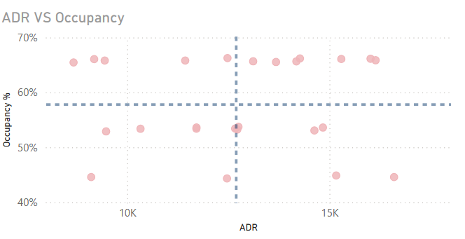

- Rating vs RevPAR Analysis:
This analysis evaluates whether customer satisfaction translates into stronger revenue performance.
Hotels with higher ratings tend to achieve stronger RevPAR performance, suggesting that service quality can support pricing power.
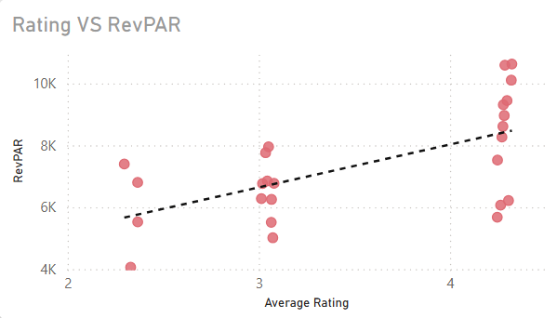

Key Insights
• Some properties operate at occupancy levels above the portfolio average, indicating potential opportunities for ADR optimization.
• Hotels with strong customer ratings tend to achieve higher RevPAR, suggesting that customer satisfaction positively influences revenue performance.
• Realisation rates are consistent across booking platforms (~69–70%), indicating that cancellation behaviour is not strongly tied to a specific booking channel.
• Revenue generation is concentrated among a smaller number of high-performing properties.
. The portfolio operates at an average occupancy of approximately 57%, suggesting there is unused capacity that could be leveraged through pricing and demand optimization strategies.

Recommendations
Based on the analysis, the following actions could improve revenue performance:
- Gradually increase ADR for hotels with strong occupancy and customer ratings.
- Focus on improving service quality for lower-rated properties to enhance revenue potential.
- Monitor booking realization patterns to identify operational opportunities for reducing revenue leakage.
- Replicate best practices from top-performing properties across the hotel portfolio.

Business Value
This analysis demonstrates how hospitality businesses can use data to optimize pricing strategy, improve customer experience, and maximize revenue performance through data-driven decision making.

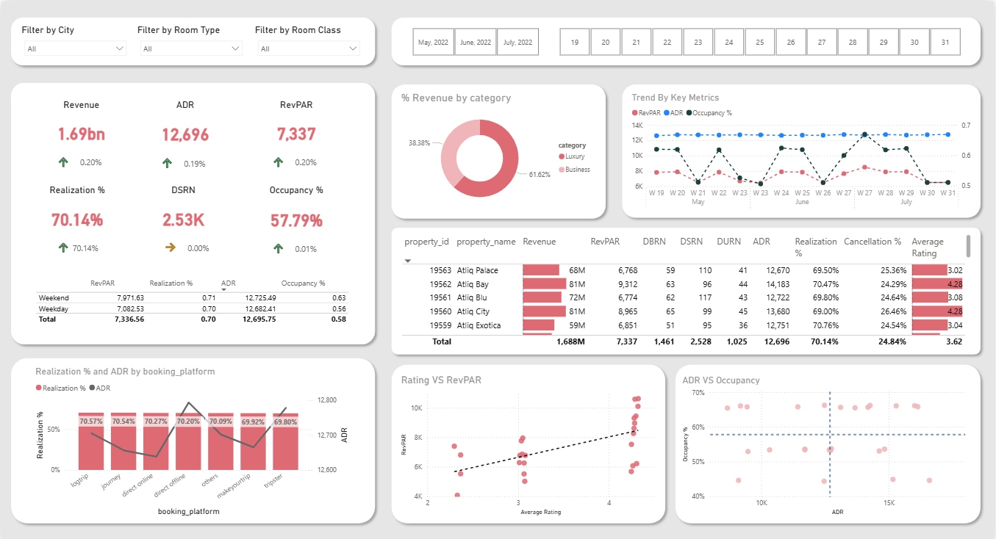
Dashboard Preview

Tools Used
- Power BI
- Excel
- DAX
Project Learnings
This project helped develop practical skills in:
- Hospitality revenue analysis
- KPI relationship analysis
- Dashboard design and storytelling
- Identifying pricing optimization opportunities using data

